**Examining Productivity Under the Ice in Northern Temperate Lakes**

Emily Whitaker

**Introduction:**

In 1969, J.R. Vallentyne made the claim that a limnologist is “[a] zoologist who, during the summertime, studies chemical and botanical aspects of geological problems in readily accessible lakes” (Vallentyne, 1969). Summer has been the historical sampling time of limnologists, and while readily accessible lakes are always a plus, work done in the polar regions has brought to light howdynamic water bodies are in the winter. While ice has been seen as a deterrent for sampling on water, recent publications have shown how to translate traditional ice-off sampling techniques to the ice on period (Block et al. 2018). There have been also been multiple publications stressing the need for winter limnology as researchers have started to unveil the complexity of frozen lakes (Hampton et al. 2015, O’Reilly 2015, Powers and Hampton 2016). To this end, Vallentyne’s assessment of limnologists no longer holds true. As changing climate shortens the duration of lake ice, it is critical to start long-term data collection to gain an understanding of the influence of ice cover on lake ecosystems.

Ice acts as an atmosphere/water barrier, sealing in nutrients and gases and closing the lake to atmospheric inputs for the season. The lake can go through a number of changes during this time, shifting from oxygen rich to oxygen poor. Limited oxygen generation may result in anoxia that leads to under-ice fish kills. Changes in ice-on and -off dates as well as decreasing total days of ice cover might be changing under ice ecology, however without observational data is unknown how ecology is changing. With air temperatures warming, more lakes will see a reduction of number of days with of total ice cover (Magnuson 2000). A global air temperature increase of 3.2 °C will impact over 50,000 lakes, which will in turn affect nearly 500 million people (Sharma et al. 2019). These changes affect economies, food accessibility, safety, access to freshwater, and local ecosystems.

Contrary to Vallentyne’s and many other historical limnologists’ beliefs, there are many ecosystem functions that occur under lake ice. A main study system used to model this is sea-ice in Antarctica where ice-associated algae and phytoplankton are responsible for up to 30% of total productivity (Arrigo and Thomas 2004). In the ocean, water is saline enough that brine channels form, which algae can inhabit to get as close to the surface as possible. This way algae are able to leverage the minimal amounts of sunlight there is to continue to photosynthesize. With active photosynthesis occurring there is a reduction of potential for anoxia. The productivity, algal growth, and oxic conditions then impacts what happens throughout the following seasons, which may impact the next winter season. Northern temperate lakes are not saline enough to create brine channels in the ice; but air bubbles and ice fractures can form allowing sediments and primary producers to sit higher in the ice. It is relativity unknown how large of a contribution winter productivity plays in total productivity in temperate lakes.

The main driver of both winter and summer primary productivity is sunlight. However, not all sunlight is usable for producers. Photosynthetically Active Radiation (PAR), which is part of the visible light spectrum, drives photosynthesis. PAR transmission underwater is highly dependent on surface conditions. In the winter snow is the largest determinate of how far in the water column PAR can travel. In a snow free environment 95% of PAR can infiltrate the ice into the water. In contrast, when there is a layer of snow roughly 2% of the light enters the column, and when the snow depth is 13.5cm or greater no light can penetrate the water column (Hampton et al. 2015, Wetzel 2001, Hampton et al. 2017).

In my graduate research I hope to address a subset of larger winter limnological questions, including: Is PAR availability beneath lake ice the dominant control of algal communities? How do changing light conditions impact seasonal productivity in frozen northern temperate lakes?I will take two approaches to understand the dynamic ecology under lake ice. First, I will analyze 30 years of phytoplankton slides from Sparkling Lake in Vilas County, Wisconsin, to comprehend how community compositions have been shifting over time. The second part of my thesis will focus on looking forward, preforming a lake manipulation study on South Sparkling Bog. I will be removing the all snow from the bog to model changes in precipitation and changing ice-on periods. **I hypothesize that light availability is the major driver of winter productivity and controls the seasonal dynamics of under-ice algal communities***.*

**Chapter 1: Long term drivers of Phytoplankton Community Composition**

The LTER has been sampling phytoplankton from their lakes since 1983. These samples are collected at the epilimnion, metalimnion, and hypolimnion, preserved in Lugol’s solution, and then hypsometrically pooled. Pooled samples are sent to PhytoTech Labs (Kanas City, Kanas) to be further preserved on mounted slides. Select sets of these slides have been examined at PhytoTech for community composition, however the majority of them have not. Out of the subset of analyzed slides all of them are from the summer months. All slides, analyzed and non-analyzed, are stored in Noland ZoologyMuseum at UW-Madison’s campus.

My analysis will focus on slides from Sparkling Lake, a 63 ha seepage lake in Vilas County, Wisconsin that often has higher concentrations of chlorophyll-a in the winter than the summer. This indicates that under ice phytoplankton may be a significant contributor to annual primary production. Interestingly, lakes in the surrounding area do not show the same high winter chlorophyll patterns (Figure 1). Understanding under ice ecology provides a baseline to assess future productivity associated with lake-ice loss. Through analyzing these slides I predict that we will see changes in seasonal and yearly patterns will emerge.This study will not only create one of the longest histories of phytoplankton community compositions for the LTER but also give indication to what causes changes in community composition.

*Sampling Site*:

Sparkling Lake was chosen for this study since it is an LTER lake, allowing us to access a wealth of data on the lake including 30+ years of slides, and yearly collected biology and chemistry data. Sparkling Lake also has an abnormally large amount of chlorophyll in winter compared to surrounding lakes making it an interesting study system (Figure 1).

*Methods:*

Phytoplankton counts will be conducted via microscopy and biomass will be compared with chlorophyll-a concentrations, snow depth, and ice thickness. From this, we can infer the chlorophyll-a to carbon content of phytoplankton and assess the degree to which winter production is important on a seasonal basis.When using microscopy, slides communities will be counted until 500 individuals have been counted or 5 transects have been completed. To evaluate the impacts of environmental factors on the community snow and ice growth

Comparison to snow thickness and ice depth, light data are available using the LTER records.

*Progress to Date*:

In the fall I started communication with Dr. St.Amand, the chief scientist at PhytoTech to better understand the methods used to do the previous counts. I am still in contact with Dr. St.Amand so if any slides or phytoplankton were challenging to identify. Slides from Sparkling Lake have been collected from the Zoology museum in Noland.

Thomas Shannon, a limited term employee at the Center for Limnology and recent UW-Madison graduate, is examining the slides. Any species that Tommy has issues identifying he shows to Dr. Rex Lowe who is staying in the loop on this project and visits semi-weekly. Twenty-one slides, over six year span, have been examined so far.

We have noticed that slides dated before 1990 are too disintegrated to identify using the microscopes available at the Center for Limnology. A cap-ex request was placed and approved for a higher magnification scope.

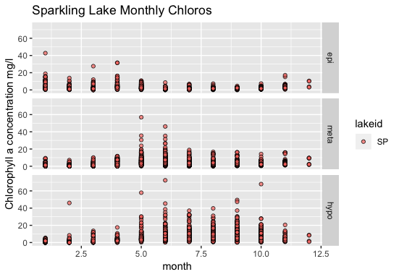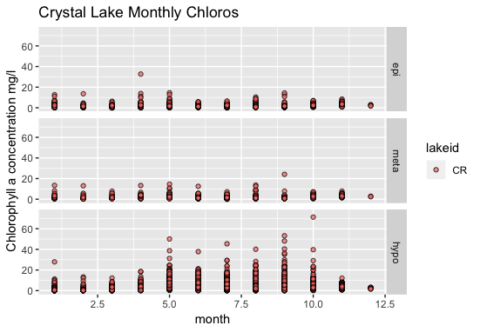

Figure 1: Graphs of chlorophyll concentrations (mg/l) in Sparkling and Crystal Lakes over the course of the year, recorded for 30 years. On the x-axis, January is on the left and December is on the right. Note the generally higher chlorophyll levels in the epilimnion in the winter in Sparkling Lake compared to Crystal Lake.

|  |  |  |  |
| --- | --- | --- | --- |
|  | South Sparkling Bog | Trout Bog | Sparkling Lake |
| Max Depth | 8 m | 7.9 m | 20 m |
| DOC (mg/l) | 21.92 | 20.58 | 2.99 |
| Mean ice duration | 150 days | 154 days | 136 days |
| Mixing regime | Dimictic | Dimictic | Dimictic |
| pH | 4.94 | 4.78 | 7.4 |
| Area | 0.44 ha | 1 ha | 63 ha |
| Secchi depth | 1m | 1m | 6.2 m |

Table 1: Comparison of lake characteristics in three major study sites.

*Historical analysis of sparkling lake phytoplankton community:*

*Question: how does phytoplankton in sparkling lake vary through time?*

*Objective: quantify phytoplankton abundance and biomass in sparkling lake relative to abiotic winter drivers*

*Predictor variables: chlorophyll a, snow depth, ice thickness*

*Response variables: phytoplankton abundance, phytoplankton biomass (pooled across species?)*

* *How far along on slides being analyzed? Do we have counts?*

**Chapter 2: Lake Manipulation**

The second component of my thesis will be a lake manipulation experiment. This experiment is designed to model the warmer winters Wisconsin and other northern temperate zones will be experiencing in upcoming years (O’Reilly et al. 2015, Pernica et al. 2017, Krasting et al. 2013). It is pertinent to collect data and understand what will happen in the future as we are already seeing areas where the ice and snow have been affected by climate change. In the 2007/08 winter a significant warming event in Northern Scandinavia caused snow to melt from lakes quickly while in the United States, Alaska is warming rapidly, this March some areas have seen a temperature increases of 20F higher than average (Livingston 2019, Garcia 2019). Being able to fully understand or make predictions of how events like these will affect water bodies will be beneficial to regional groups for safety and economic forecasting.

To model the expected changes in climate my team will attempt to remove snow from South Sparkling Bog within 48 hours after a snow event throughout the entire ice-on season while keeping Trout Bog as a reference lake. These are suitable comparison lakes as they have very similar characteristics (table 1) and are roughly 2.5 miles apart.Similar experiments have primarily examined the short-term effects of snow removal focusing on snow removal at the end of the season (Garcia 2019, Juhl and Krembs 2010, Wipf and Rixen 2010).

Other studies that have examined snow removal have seen timing of the removal is important for the understanding of winter productivity. A Juhl and Kerbs 2010 study shows that partial snow removal can affect *in-situ* algalblooms. The study team removed certain percentages of snow from the ice ranging from 100% snow removal to 5%. Unexpectedly, in the region with 100% snow removal, saw an immediate decrease in algal biomass with the researchers concluding that the prevalent phytoplankton had become shade adapted and were put in stress once introduced to an increase in PAR (Juhl and Krembs 2010). However, the study was done was done two weeks before the predicted ice off date. In a two-week boreal lake study, teams found that removing snow increased methane concentrations, decreased depth specific phosphate levels, stimulated algal productivity and decreased the relative abundance of methanotrophic bacteria (Wipf and Rixen 2010). These two-week partial removal studies show the magnitude snow makes on the lake environment. By altering completing a full season removal I hope to see the full effect of these changes.

Fast snow removal will mitigate the insulating effects of snow as well as reduce the potential for slush build up. Without slush and snow light attenuation allowing will increase for more primary productivity to occur under the ice surface. Additionally, without the layer of snow, the ice is predicted to melt at an earlier date than normally. Removing snow will create a scenario where there should be only black ice allowing the maximum about of PAR to penetrate the ice and water column.

Theoretically productivity will increase under the ice as there will be more light for primary producers to utilize. With the increase in primary production, DO and chlorophyll levels are also expected to increase compared to the baseline year. I further hypothesize that during the manipulation year we will see more black ice, changes in the biological make up of the ice with fewer methanotrophic bacteria, earlier ice off and changes in DO.

*Study Sites*:

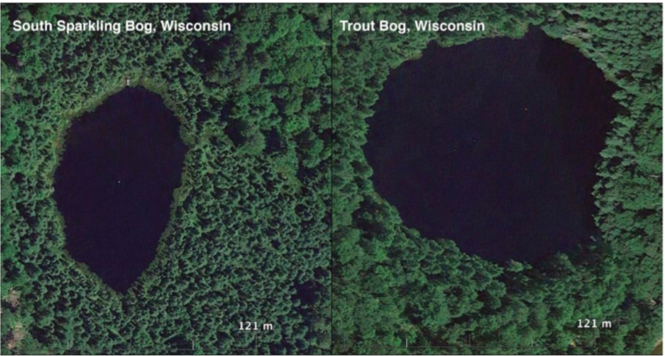Sites used in this study will be South Sparkling Bog and Trout Bog. These two sites were chosen due to the abundance of similarities and wealth of LTER data on Trout Bog (Table 1).

Figure 1. Map of sampling sites, South Sparkling Bog on left, Trout Bog on the right.

*Methods*:

In 2018/19 I will be sampling the research sites once a month from fall mixing to spring mixing. Trout Bog is an LTER study lake, which has open-access data dating back to 1983. While South Sparkling Bog is not a LTER lake, it is located 300 meters from Sparkling Lake, a LTER lake, and general weather trends should be able to approximate trends on South Sparkling Bog. Meteorological data from Sparkling Lake shows that it consistently receives snow from January to March, peaking in February with roughly 14 cm, and has approximately 150 days of ice cover.

Data collection follows a slightly altered LTER winter sampling protocol. Differences in the sampling routine include, lack of Schindler Trap, collecting ice cores, and not pooling our phytoplankton, rather analyzing the epilimnion and hypolimnion samples apart and then examining the pooled sample. Unlike the LTER we will not be using Schindler Traps to sample for zooplankton, instead taking a Wisconsin Net integrated tow.

During both the control and manipulation years, ice cores will be taken from South Sparkling Bog and Trout Bog. These cores will be analyzed using 18S RNA sequencing which will identify any eukaryotes living in the ice. To perform this analysis the ice cores will be separated into black and white ice components, melted, and filtered. In coordination with UW-Madison’s Biotech Center and Next-Gen Sequencing the filtered samples will be sequenced on campus. The nuclear signature of the communities in each layer of the cores will be reported back. The samples collected and analyzed in the control year will then be compared to the manipulation year as well as ice depth, snow thickness, and PAR measurements to see potential relations.

The sequencing will be done in two parts, firstly I will be working with the McMahon lab to filter and prepare samples for sequencing. Using DNeasy PowerWater Kit the kit will allow us to prepare the sample for Biotech. After preparing the samples they will be sent to the Biotech Center where the center will preform a quality control on the total batch of samples. Once quality control has been done the center will run a micro 18S run the batch.

To sample under-ice conditions, sensor buoys were deployed in both bogs. The buoys float beneath the ice surface, sampling from before ice-on to ice-off. The buoys were designed and built fall 2018 and will measure dissolved oxygen, chlorophyll, and carbon dioxide at 1m below the ice, as well a full temperature and light profile. Monthly manual measurements will follow winter LTER protocols for chemical and biological observations. We will also be taking EXO YSI depth discrete profiles on our sites. The YSI measures pH, fDOM, turbidity, conductivity, optical DO, and algal biomass.

In following winters, the snow of South Sparkling Bog will be manipulated while Trout Bog will be used as a control lake. A local Vilas County hire and I will use an industrial snow blower to clear the snow. By frequently clearing the snow the maximum amount of PAR will be let into the water column and a slush layer won’t form. This will also allow us to get the most accurate understanding of how the communities under the ice are changing. As noted in the Juhl and Krembs study, when 100% of the snow was removed the phytoplankton all died due to the intense change in light (Juhl and Krembs 2010). By having a snow-free system for the season the phytoplankton should become light adapted. Statistical analyses will use a variety of comparative ecological methodologies such as mixed-effect models and hierarchical linear models.

*Experimental removal of lake snow effects on under-ice productivity*

*Question: how does the continuous removal of snow affect the under-ice productivity of South Sparkling Bog?*

*Objective: quantify lake productivity (as…???) relative to multiple increased light availability due to the experimental removal of snow*

*Response variable = lake productivity as measured as… (combo of temp, CO2, DO?), Chl-a?, algal biomass?*

* *I’m a dummy – how do you calculate lake productivity? Also could look at chl-a and algal biomass as response first?*

*Predictor variable = light availability as measured as PAR*

* *Do you have direct measurements of snow depth and/or ice thickness?*

*I don’t fully understand the ice cores bit… - there is a lot here already, maybe that is a separate project?*

*Progress to Date:*

Completed baseline winter data collection on northern lakes. Started to preliminarily analyze the collected data. Begun to cut down ice cores with in coordination with Zoet lab.

**Year 1 Field data collection:**

The Northern sampling season spanned from November 8th 2018 to April 6th 2019 with sampling events occurring monthly. In November only South Sparkling Bog was sampled as Trout Bog had iced over. In late November buoys were placed under the ice in both Trout and South Sparkling Bogs. Biological and chemical data for Trout Bog are collected by the LTER base crew a week before my sampling events, therefore we choose to only collect a light profile, secchi depth, a sonde profile, and an ice core. In January both bogs were sampled using the full methods outlined above. Starting in February Sparkling Lake was added to the rotation of lakes surveyed in the Trout Lake region. On Sparkling Lake we sample for ice cores, secchi depth, and take sonde and light profiles. All three lakes were sampled in the same manner in during the first weeks of March and April.

**Proposed Schedule:**

August 2018-December 2018:

TA ZOO 316, completed ZOO 750, ZOO 953, and ZOO 955, applied to NSF GRFP

November 2018-April 2019:

Baseline Northern Sampling

October 2018- May 2019:

Phytoplankton slide analysis

January 2019-May 2019:

ZOO 955, SSCC R Course, applied and received Anna Birge Grant, presented at USGS NECASC meeting, presented at LTER March Meeting, analyzing phytoplankton slides, analyzing northern data, Mendota winter sampling, ZOO 316 preparation

April 2019:

Writing Master’s proposal and Committee meeting

Summer 2019:

Three sampling events on South Sparkling Bog including finding bathymetry.

September 2019-December 2019:

DELTA mentoring class, head TA for ZOO 316, ZOO 955, ZOO 911, process ice samples

November 2019-April 2020:

Monthly Northern Sampling

April 2020:

Data publishing

May 2020- December 2020:

Committee meetings and thesis writing, northern sampling methods/results paper

December 2020:

Graduate

|  |  |  |  |  |  |  |  |  |  |
| --- | --- | --- | --- | --- | --- | --- | --- | --- | --- |
| **Task** | **Year 1** | | | **Year 2** | | | | **Year 3** | |
|  | Fall | W | Spr | Sum | Fall | W | Spr | Sum | Fall |
| Zoo 316 TA | **X** |  |  |  | **X** |  |  |  |  |
| Baseline sampling |  | **X** | **X** |  |  | **X** |  |  |  |
| Present work |  |  | **X** |  |  |  | **X** |  | **X** |
| Phytoplankton | **X** | **X** | **X** | **X** |  |  |  |  |  |
| Snow removal |  |  |  |  |  | **X** | **X** |  |  |
| Write Thesis |  |  |  |  |  |  |  | **X** | **X** |
| Courses | **X** |  | **X** |  | **X** |  | **X** |  |  |
| RNA sequencing |  |  | **X** |  |  |  | **X** |  |  |
| Manuscripts |  |  |  | **X** | **X** | **X** | **X** | **X** | **X** |

*Deliverables*:

* Poster presentation of phytoplankton slide work at 2019 SFS meeting in Salt Lake City
* Phytoplankton results paper to be started at end of 2019
* Paper on snow manipulation experiment (methods and results?)
* Presentation of snow manipulation experiment at ASLO 2020 Summer Meeting in Madison

**Additional research:**

In addition to preforming work towards my thesis I hope to be engaged with the CFL and larger UW-Madison communities. My first collaboration towards this goal was to co-lead the effort on weekly winter Mendota sampling with Patricia Tran of the McMahn lab and Quinn Gavin, an undergraduate who works with Dr. Stanley. Our goal in this was to continue the weekly sampling procedures from the 2017/18 winter as well as coordinate with other labs who may be interested in winter data. We then could make a sustainable sampling plan that would continue for years to come. After assembling an undergraduate sampling team and our finalized procedures we sampled every safe week from late January to mid March. Currently Patricia and I are working on the best methods to share data between lab groups.

I have been mentoring two undergraduates, one who is getting paid to do research the other who is doing this research as class credit. Sam Ahler’s project will be a two-semester ordeal. The overarching goal of his project is to analyze organisms and microbes in the ice cores. He will be using ice cores that the winter sampling team collected from Mendota, South Sparkling Bog, Sparkling Lake, and Trout Bog. Sam will coordinate with the McMahon lab on melting and filtering in order to prepare the ice 18S RNA sequencing in the fall.

Alaina Eckert is a member of the class of 2019 and is getting course credit through the research she is doing with Hilary. Alaina has been coming up to Trout Lake to assist with sampling procedures. Her deliverable in this project will be writing a scientific paper outlining the impacts of snow thickness and length of ice cover on LTER lakes. She will also be comparing chlorophyll-a levels and dissolved oxygen concentrations to these metrics. We decided a feasible number of lakes to study would be four. She will be looking at trends between Sparkling Lake and Crystal Lake as well as trends between Crystal and Trout Bogs; if there is enough data available she will also examine South Sparkling Bog.

**References**:

[1] Vallentyne, J. R. (1969). Definition Of A Limnologist. Limnology and Oceanography, 14(5), 815- 815. doi:10.4319/lo.1969.14.5.0815

[2] Block, Benjamin D., et al. (2018) The Unique Methodological Challenges of Winter Limnology. *Limnology and Oceanography: Methods*, doi:10.1002

[3] Hampton, S. E., Moore, M. V., Ozersky, T., Stanley, E. H., Polashenski, C. M., & Galloway, A. W. (2015). Heating up a cold subject: Prospects for under-ice plankton research in lakes. *Journal of Plankton Research, 37*, 277-284.

[4] O’Reilly, C. M., et al. (2015), Rapid and highly variable warming of lake surface waters around the globe, Geophys. Res. Lett., 42, 10,773–10,781, doi:10.1002/ 2015GL066235.

[5] Powers, S. M., & Hampton, S. E. (2016). Winter Limnology as a New Frontier. *Limnology and Oceanography Bulletin,25*, 103-108. doi:10.1002/lob.10152

[6] Magnuson, J. J. (2000), Historical trends in lake and river ice cover in the Northern Hemisphere, Science, 289(5485), 1743–1746, doi:10.1126/ science.289.5485.1743.

[7] Sharma, S. et al. (2019). Widespread loss of lake ice around the Northern Hemisphere in a warming world.  Nature Climate Change 9: 227-231. https://doi.org/10.1038/s41558-018-0393-5

[8] Arrigo, K. R. and Thomas, D. N. (2004). Large scale importance of sea ice biology in the Southern Ocean. Antarct. Sci., 16, 471–486.

[9] Wetzel, R. G. (2001). *Limnology: lake and river ecosystems*. Gulf Professional Publishing.

[10] Hampton et al. (2017). Ecology under lake ice. Ecol Lett, 20: 98-111. doi:[10.1111/ele.12699](https://doi.org/10.1111/ele.12699)

[11] P. Pernica, R. L. North & H. M. Baulch (2017) In the cold light of day: the potential importance of under-ice convective mixed layers to primary producers, Inland Waters, 7:2, 138-150, DOI: 10.1080/20442041.2017.1296627

[12] Krasting, J.P., A.J. Broccoli, K.W. Dixon, and J.R. Lanzante, 2013: Future Changes in Northern Hemisphere Snowfall. *J. Climate,* **26**, 7813–7828, doi.org: 10.1175/JCLI-D-12-00832.1

[13] Livingston, I. Alaska is baking in an exceptionally toasty March as steep, long-term warming presses on. *The Washington Post*(2019).

[14] Garcia, S. L., (2019). Decreased Snow Cover Stimulates Under-Ice Primary Producers but Impairs Methanotrophic Capacity. mSphere, doi: 10.1128/mSphere.00626-18

[15] Juhl, A. R., & Krembs, C. (2010). Effects of snow removal and algal photoacclimation on growth and export of ice algae. *Polar Biology, 33*, 1057-1065. doi:10.1007/s00300-010- 0784-1

[16] Wipf, S., & Rixen, C. (2010). A review of snow manipulation experiments in Arctic and alpine tundra ecosystems. *Polar Research*, 29(1), 95-109. doi:10.3402/polar.v29i1.6054